# **CS 470 Module Two Assignment One Guide**

## Introduction

In this lesson you will build on your previous work with Docker by creating two containers, one to host an Angular frontend application and one to host a Node JS backend REST API. We will be using example applications covered in articles on the [Angular Templates](https://angular-templates.io/) website. You do not need to read the articles or build the code by hand; however, the articles do provide useful information to help your study of full stack development. For this assignment, you will make a copy of the published code and deploy it into containers.

## Summary Steps

* Create container for Angular frontend:
  + [Fork the Angular project](https://github.com/AngularTemplates/learn-angular-from-scratch-step-by-step)
  + Clone your Angular repo: git clone {your_repo} lafs-web
  + Install nvm
  + Create dockerfile
  + docker build -t node-lafs-web
  + docker run -p 4200:4200 -d node-lafs-web
* Create container for MEAN REST API backend
  + [Fork the MEAN project](https://github.com/AngularTemplates/learn-how-to-build-a-mean-stack-application)
  + Clone your MEAN repo: git clone {your_repo} lafs-api
  + Create dockerfile
  + docker build -t node-lafs-api
  + docker run -p 3000:3000 -d node-lafs-api

## Detailed Steps

### Frontend Application

The frontend application we will use to explore containerization is available on GitHub in the AngularTemplates repository "[learn-angular-from-scratch-step-by-step](https://github.com/AngularTemplates/learn-angular-from-scratch-step-by-step)". To start, you will make a copy of that repository using a process known as "[forking](https://guides.github.com/activities/forking/)".

Ensure that you are logged into GitHub and navigate to the above repository. Click the **Fork** button on the upper right of the page.

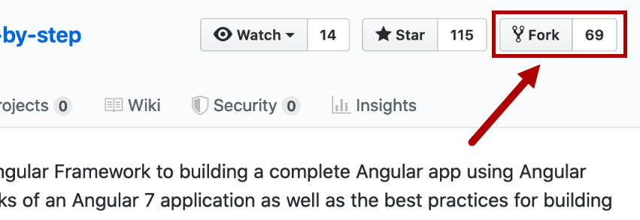

You will be taken back to your GitHub account with a new repository, named the same as the original, and a message below the title indicating that it was forked.

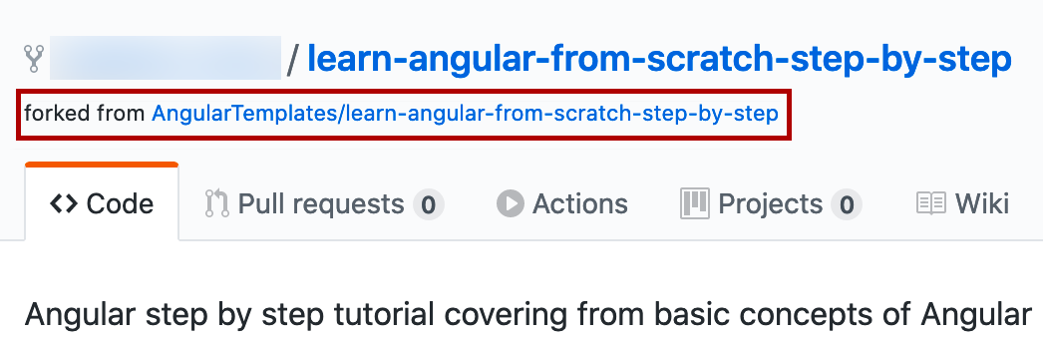

Clone your new repository into a folder on your computer.

> git clone {your-github-repo-url} lafs-web

Shows the command line interface and cloning your new repository into a folder on your computer:

> git clone {your-github-repo-url} lafs-web

An arrow indicates that "lafs-web" is the "Short folder name". 

Note: Think of the cloned repository on your computer as a "working copy".

Install nvm, the nodejs version manager. It is not unusual to have multiple projects that each run different versions of nodejs and having a version manager will let you change your nodejs version per project. You will need to uninstall any existing versions of nodejs first. Once you have nvm installed you can install the right version of node with:

> nvm install 10.23.0  
and then switch to it with  
> nvm use 10.23.0  
and double check with  
> node -v

At this point you can optionally run the application on your computer. To do so, run the following commands:

1. cd lafs-web
2. npm install -g @angular/cli@v6-lts
3. npm install
4. ng serve
5. Open a browser and navigate to http://localhost:4200
6. **Ctrl+C** to stop the web server

Create a new Docker container by creating a [Dockerfile](https://docs.docker.com/engine/reference/builder/) in the top directory of the website. Note: Make sure that your Dockerfile is named "Dockerfile" with no file extension.

Dockerfile

# using Node v10

FROM node:10

# Create app directory

WORKDIR /usr/src/lafs

# Install app dependencies

# A wildcard is used to ensure both package.json AND package-lock.json are copied

# where available (npm@5+)

COPY package*.json ./

RUN npm install -g @angular/cli@v6-lts

RUN npm install

# If you are building your code for production

# RUN npm ci --only=production

# Bundle app source

COPY . .

# Expose port 3000 outside container

EXPOSE 4200

# Command used to start application

CMD ng serve --host 0.0.0.0

Note: Refer to the NodeJS article [Dockerizing a Node.js web app](https://nodejs.org/fr/docs/guides/nodejs-docker-webapp/#creating-a-dockerfile) for more information.

Create a Docker Ignore file to indicate the files and folders that will not be copied into the container.

.dockerignore

.env

.git

.gitignore

node_modules

npm-debug.log

After creating the dockerfile and Docker Ignore file, use the Docker [build](https://docs.docker.com/engine/reference/commandline/build/) command to create a container image using the following command:

> docker build -t node-lafs-web .

***-t*** *assigns a "tag" to the image used when storing in the local Docker repository.*

Run the Docker container using the following command:

> docker run -p 4200:4200 -d node-lafs-web

***-d*** *means "detach" the console from the container so it runs in the background and lets you use additional commands.*

***-p 4200:4200*** *means to map port 4200 on your computer to port 4200 inside the container.*

At this point you can open a web browser on your computer and navigate to <http://localhost:4200>.

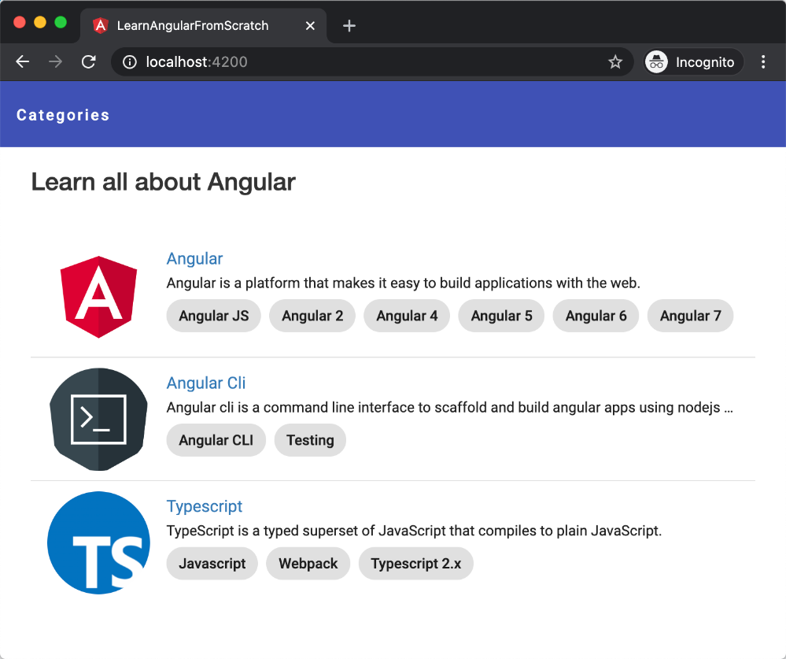

### Backend REST API

The backend application we will use to explore containerization is available on GitHub in the AngularTemplates repository "[learn-how-to-build-a-mean-stack-application](https://github.com/AngularTemplates/learn-how-to-build-a-mean-stack-application)". To start, you will make a copy of that repository using a process known as "[forking](https://guides.github.com/activities/forking/)".

Ensure that you are logged into GitHub and navigate to the repository URL: <https://github.com/AngularTemplates/learn-how-to-build-a-mean-stack-application>. **Fork** this repository as you did for the frontend application.

Clone your new repository into a folder on your computer:

> git clone {your-github-repo-url} lafs-api

At this point you can optionally run the application on your computer. To do so, you will need to install Node JS and run the following commands:

1. cd lafs-api
2. npm install
3. npm run start
4. Open a browser and navigate to http://localhost:3000/
5. **Ctrl+C** to stop the web server

Create a [Dockerfile](https://docs.docker.com/engine/reference/builder/) in the top directory of the website, similar to what you did for the frontend application. Refer to the NodeJS article [Dockerizing a Node.js Web App](https://nodejs.org/fr/docs/guides/nodejs-docker-webapp/#creating-a-dockerfile) as needed. This file will be a little different than your other Dockerfile.

After creating the dockerfile and Docker Ignore file, use the Docker [build](https://docs.docker.com/engine/reference/commandline/build/) command to create a container image using the following command:

> docker build -t node-lafs-api .

***-t*** *assigns a "tag" to the image used when storing in the local Docker repository.*

Run the Docker container using the following command:

> docker run -p 3000:3000 -d node-lafs-api

***-d*** *means "detach" the console from the container so it runs in the background and lets you use additional commands.*

***-p 3000:3000*** *means to map port 3000 on your computer to port 3000 inside the container.*

At this point you can open a web browser on your computer and navigate to http://localhost:3000/.

You will receive an error because the backend REST API is looking for a MongoDB instance to connect to. In the next lesson, you will use more advanced Docker techniques to get multiple containers working together and able to interact over the network.

### Loopback

A helpful aspect of the example application is the use of [LoopBack](https://loopback.io/lb3) to build the REST API. LoopBack is a framework that saves time by "discovering" the models in your project and automatically generating all the REST endpoints without you having to code every one of them by hand. Another useful feature is the [API Explorer](https://loopback.io/doc/en/lb3/Use-API-Explorer.html), consisting of generated documentation and the ability to test the endpoints right from the documentation pages without having to create client code to invoke the endpoints.

Here is an example of the API Explorer from the documentation:

